Listen Up
  - Code Review

Mohammad Nazibul Kabir Khan
4263308
Contents
Reviewed Codes 4
Advanced statistics reviewed by: Lars Kluijtmans 4
Basic statistics reviewed by: Lars Kluijtmans 5

Reviewed Codes

Advanced statistics reviewed by: Lars Kluijtmans
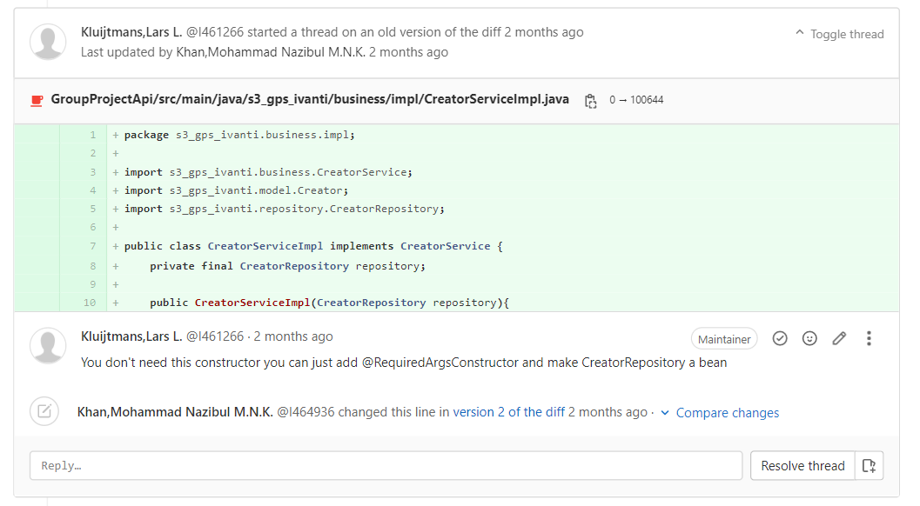
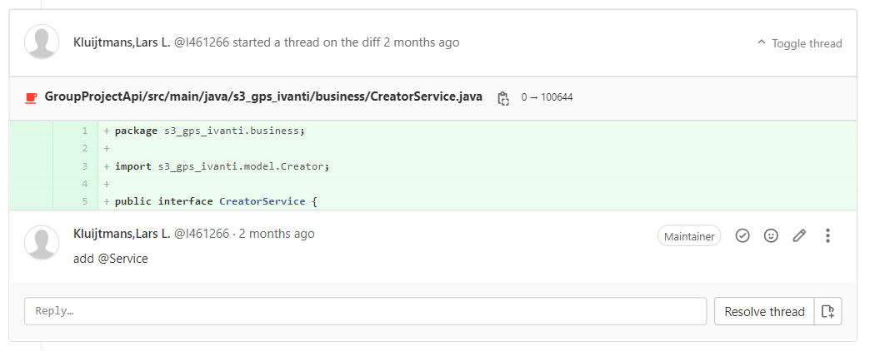
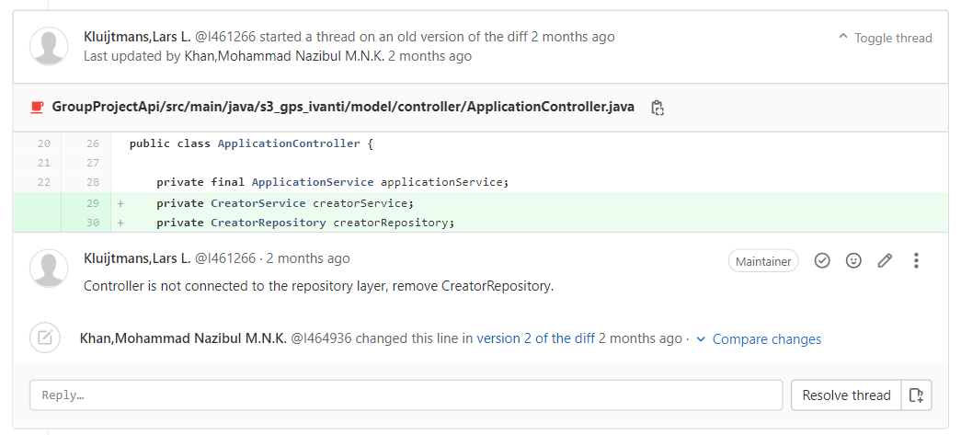

Basic statistics reviewed by: Lars Kluijtmans
